Week-2
- a) Create and attach an EBS volume to an EC2 instance, and
- scale the instance by increasing CPU and RAM by changing the instance type.
2.Attach and permanently mount an EBS volume to a Linux EC2 instance to ensure data persistence across reboots.
3. Create a snapshot of the attached EBS volume and use it to create and attach a new volume to an EC2 instance in another AWS region.

- a) Create and attach an EBS volume to an EC2 instance, and
- scale the instance by increasing CPU and RAM by changing the instance type.

- Creating and attaching an EBS volume to an EC2 instance
Step 1: Create a New EBS Volume
Open the EC2 Dashboard.
From the left-hand menu, select Volumes under Elastic Block Store (EBS).
Click Create Volume.
Choose:
Volume type (gp3/gp2)
Size of the volume
Availability Zone (must be the same as the EC2 instance)
Click Create Volume.
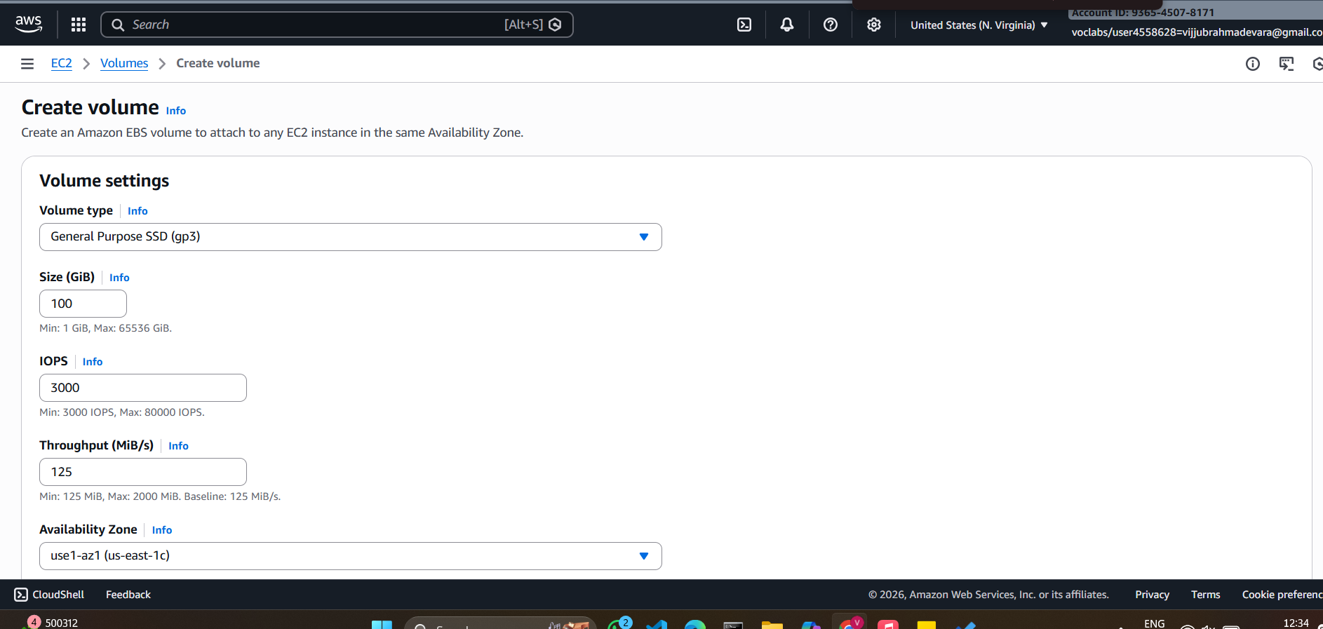

Step 2: Attach the EBS Volume to the Existing EC2 Instance
In the Volumes section, select the newly created volume.
Click Actions → Attach Volume.
Select the target EC2 instance from the list.
Specify the device name (example: /dev/xvdf).
Click Attach.
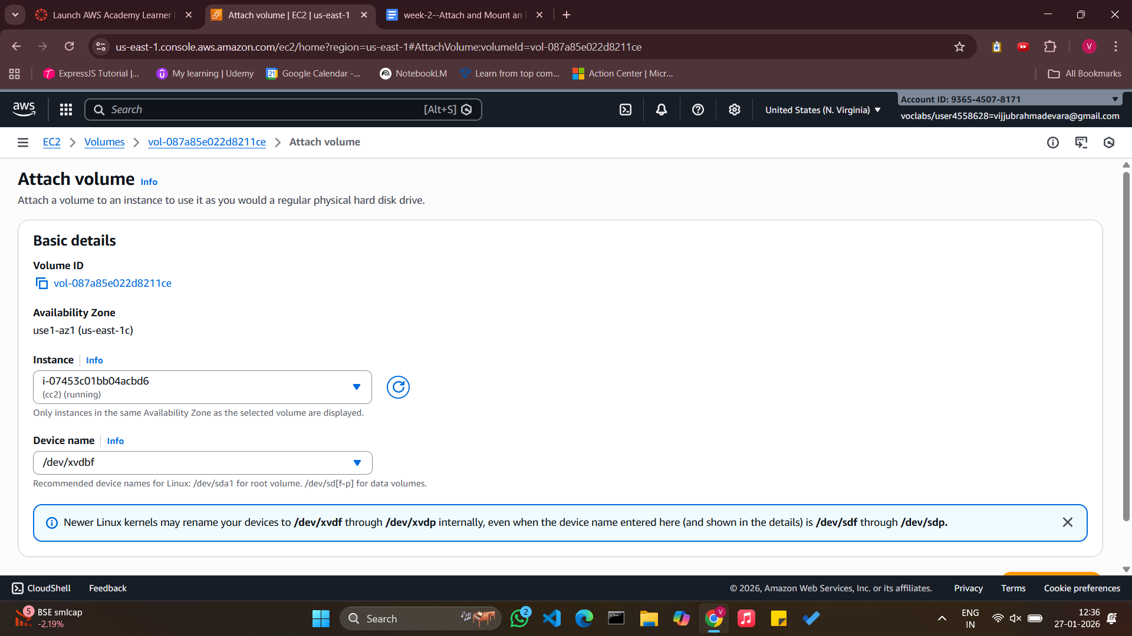
Step 3: Verify the Volume on the EC2 Instance
Connect to the EC2 instance using SSH.
Check the attached disks:
lsblk
Identify the new volume (e.g., /dev/xvdf).

Note: Ensure that the EBS volume and the EC2 instance belong to the same Availability Zone, as cross-AZ attachment is not supported.
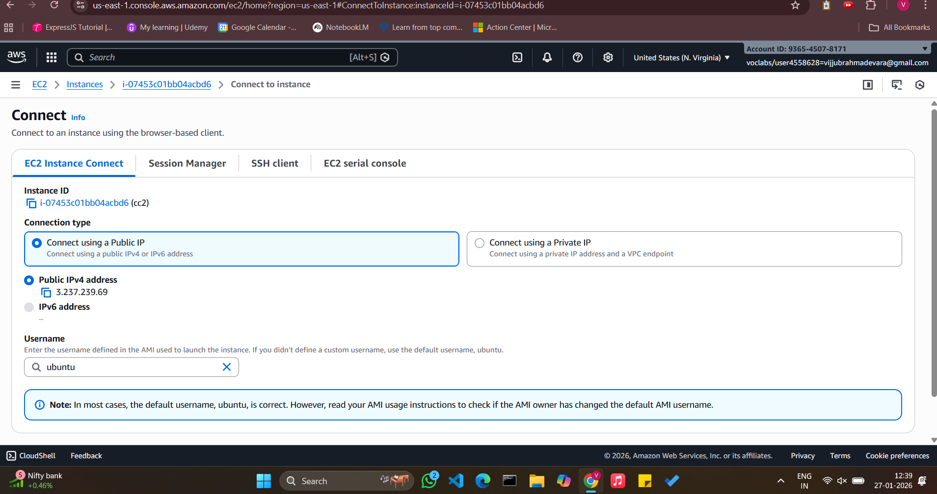
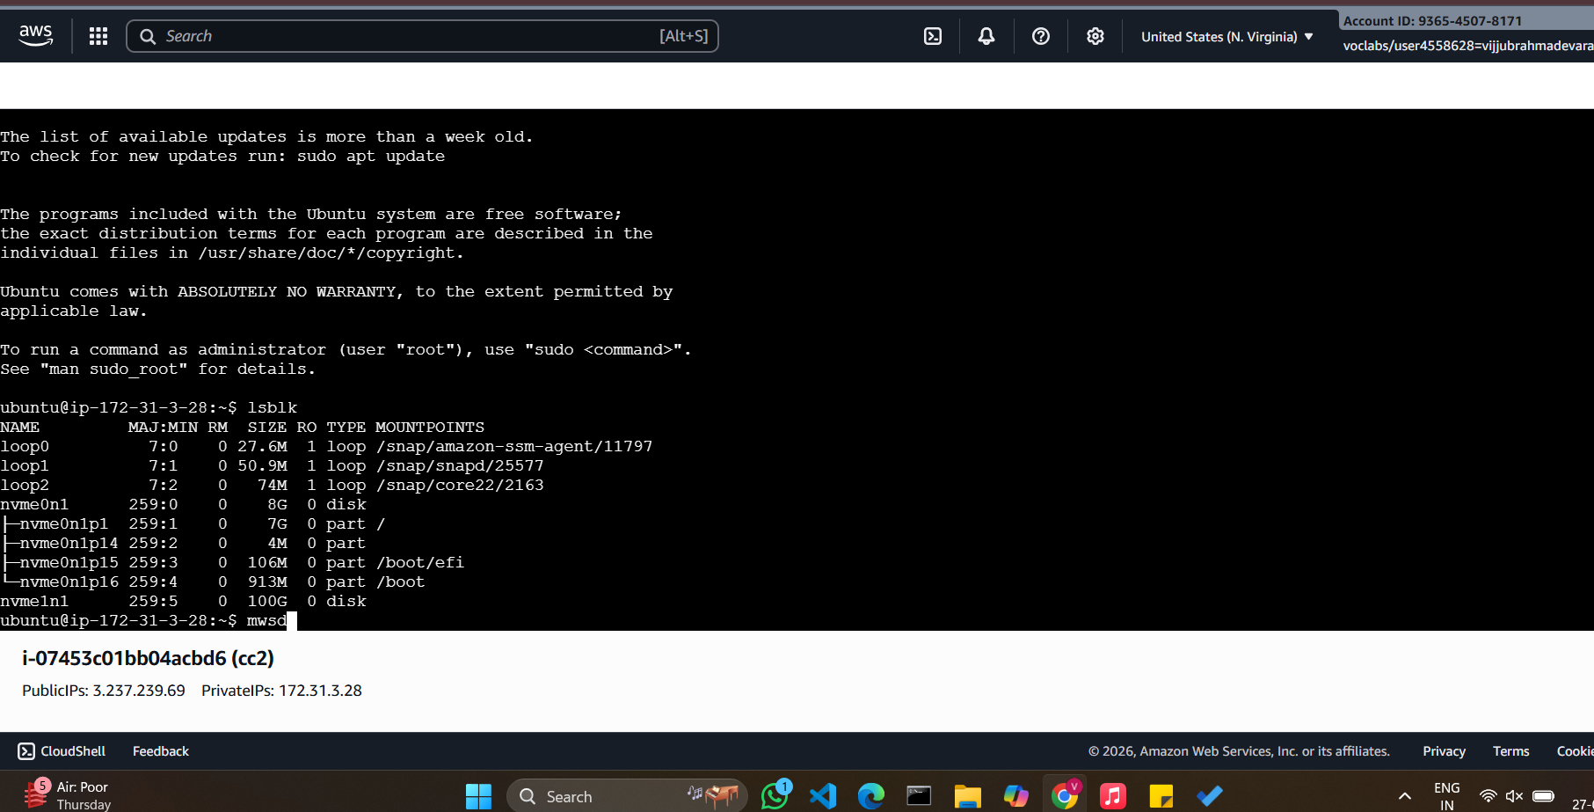

b)Procedure: increasing/decreasing of CPU and RAM
Step 1. - Navigate to the EC2 dashboard.
Step 2. - Stop the EC2 instance associated with the EBS volume.
Step 3. - Click "Actions" and then—instance settings—change the instance type"Modify Volume".
Step 4. -Increase/ decrease the size or change the volume type to a higher performance specification.
Step 5. - Click "Modify" to apply the changes.
Step 6: Now the start the machine you see with increase /decrease of size and performance
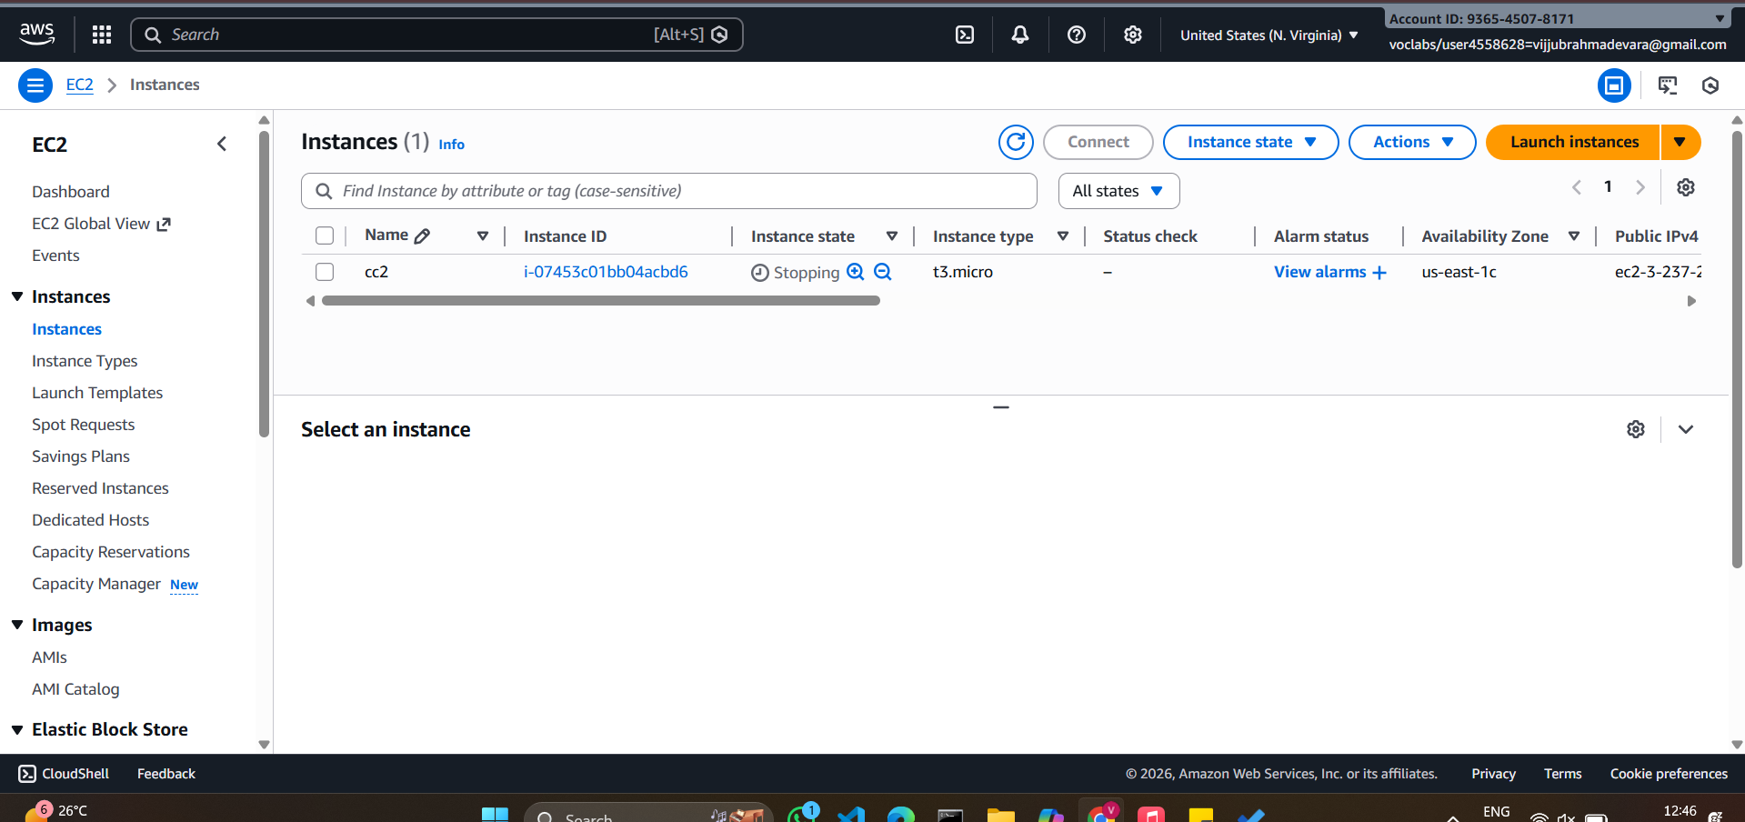
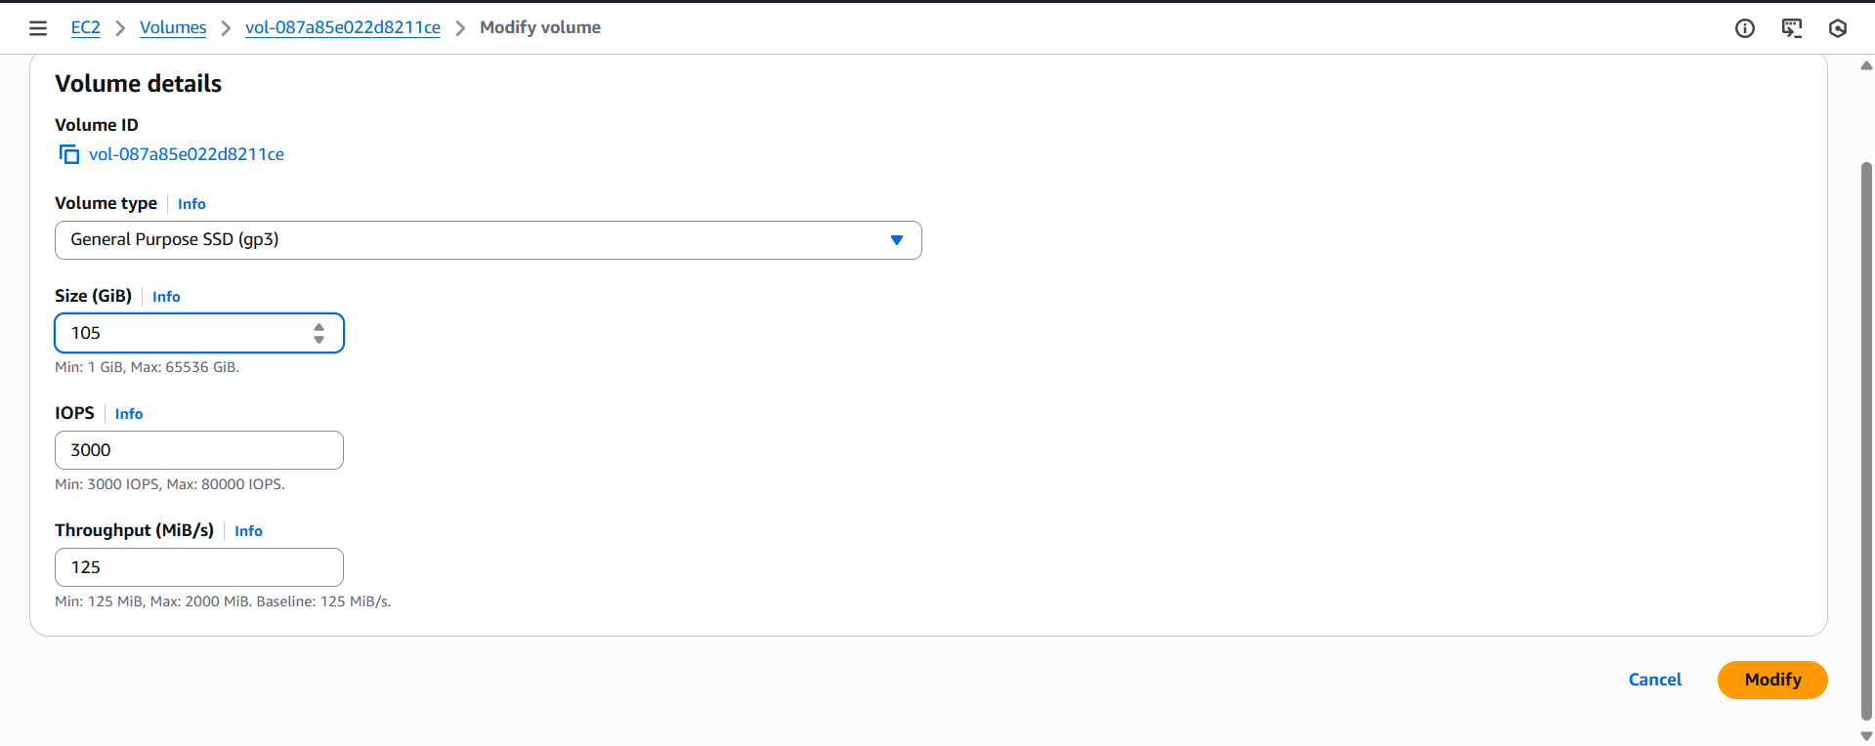
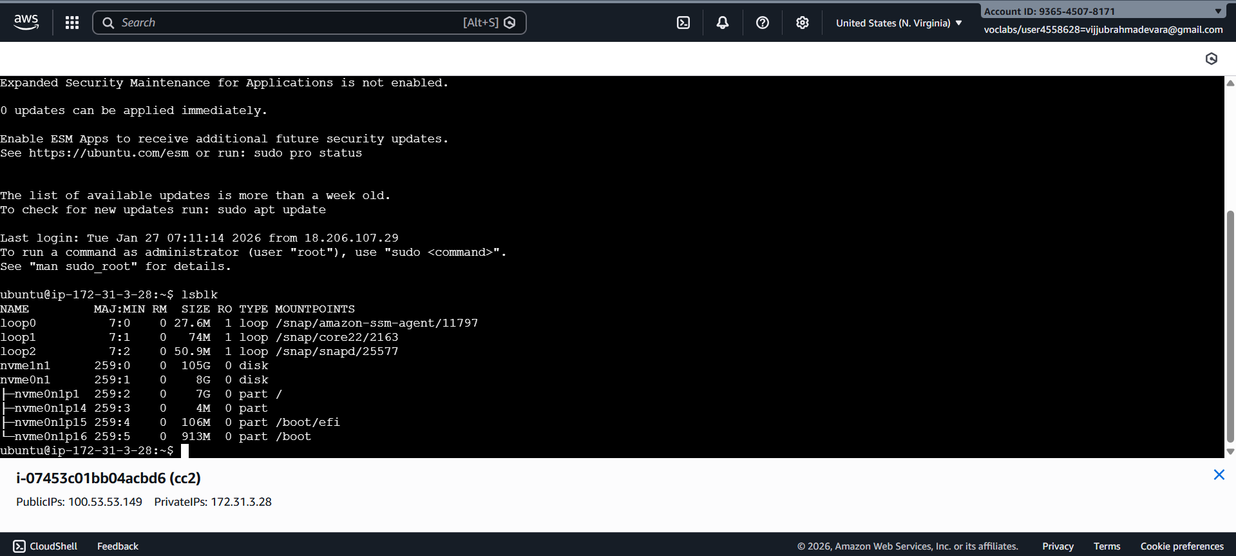

2.Attach and permanently mount an EBS volume to a Linux EC2 instance to ensure data persistence across reboots.
Step 1: Create an EBS Volume
- Log in to AWS Management Console
- Go to EC2 → Volumes
- Click Create Volume
- Choose:
  - Volume Type: gp3 (recommended)
  - Size: (e.g., 20 GB)
  - Availability Zone: Same AZ as EC2 instance
- Click Create Volume
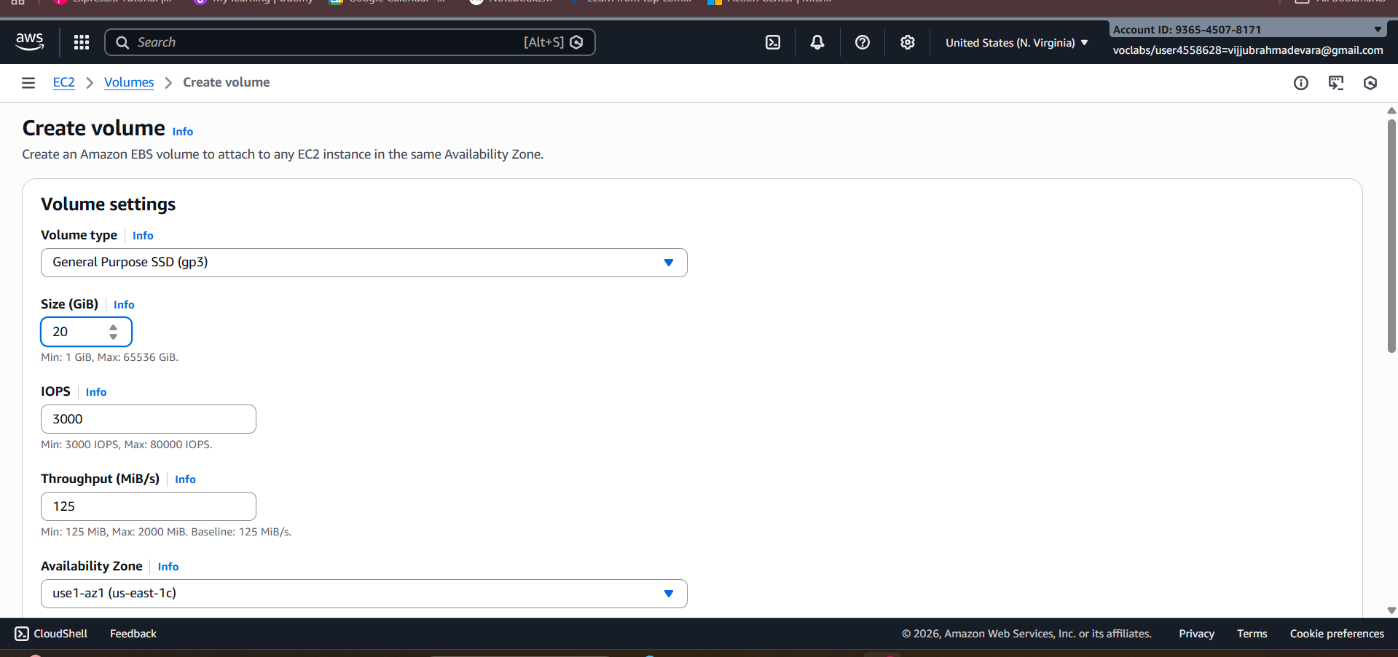

Step 2: Attach the EBS Volume to EC2
- Select the newly created EBS volume
- Click Actions → Attach Volume
- Choose:
  - Instance: Select your Linux EC2 instance
  - Device name: /dev/xvdf
- Click Attach
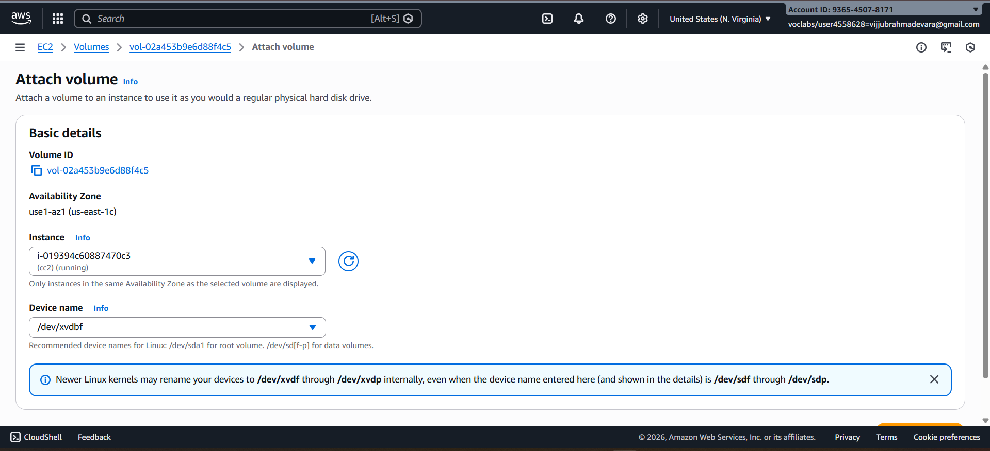

Step 3: Connect to the EC2 Instance
Connect using SSH:
ssh -i key.pem ec2-user@<public-ip>

Step 4: Verify the Attached Disk
Check all available disks:
lsblk
You will see:
- Root volume: /dev/xvda
- New volume: /dev/xvdf (no partition yet)
Check filesystem:
lsblk -fs
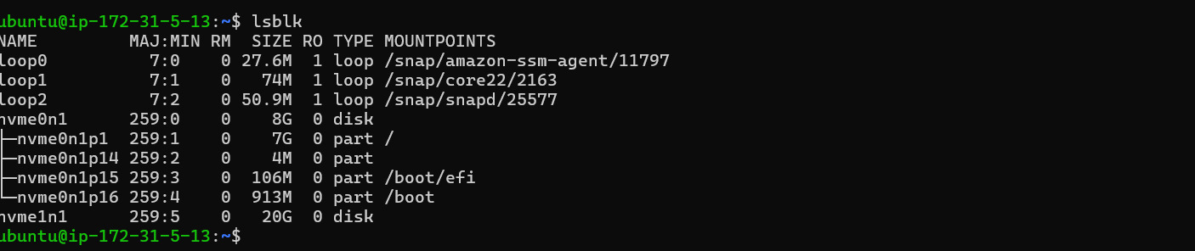
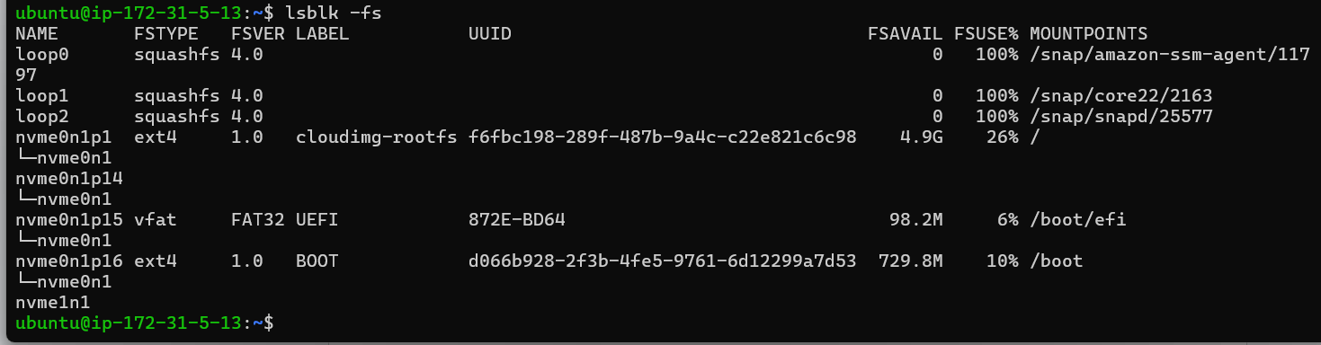

Step 5: Create a Partition
Create a partition on the new volume:
fdisk /dev/xvdf
Inside fdisk:
- Press m → Help menu
- Press n → New partition
- Press p → Primary partition
- Press Enter → Default partition number
- Press Enter → Default first sector
- Press Enter → Default last sector (use full disk)
- Press w → Write changes and exit
Notify kernel:
partprobe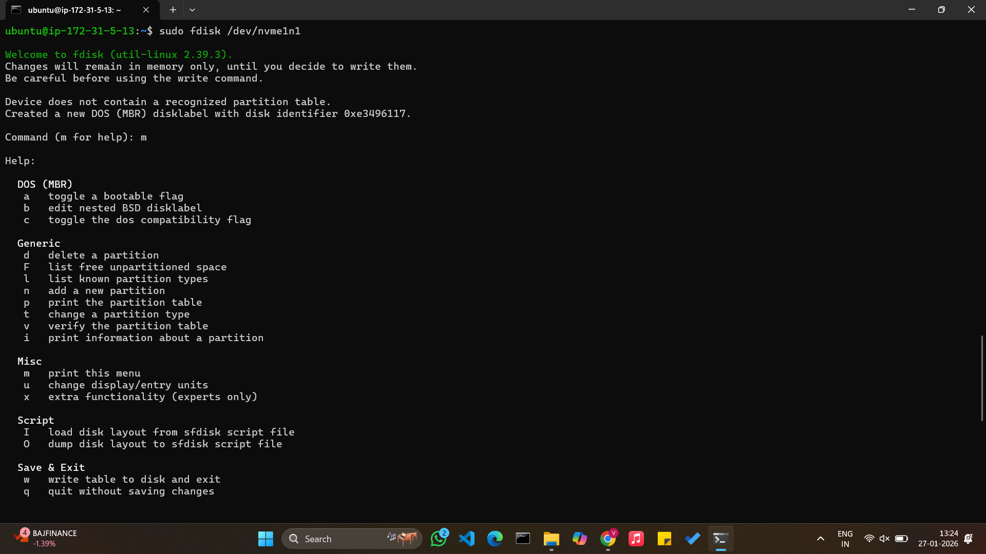
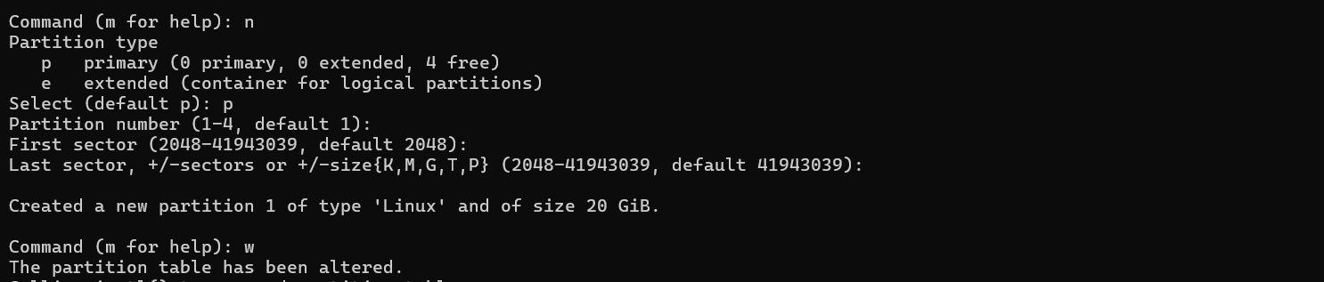

Step 6: Verify the New Partition
lsblk -fs
You should now see:
/dev/xvdf1
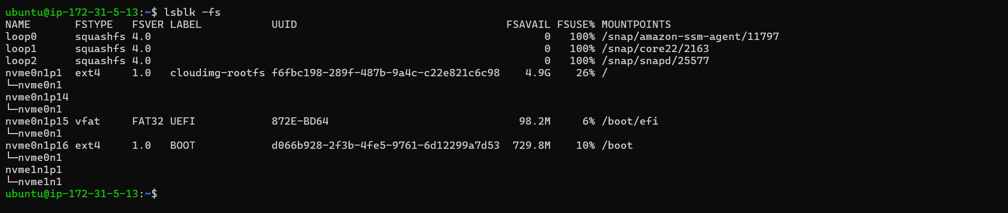

Step 7: Format the Partition
Format with XFS filesystem:
mkfs.xfs /dev/xvdf1
Verify:
lsblk -fs
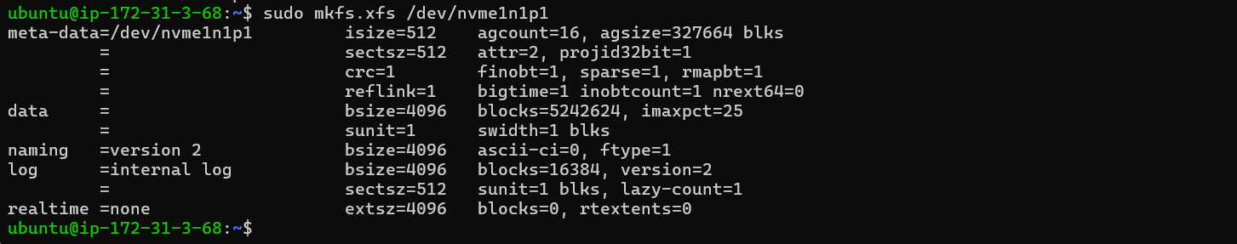
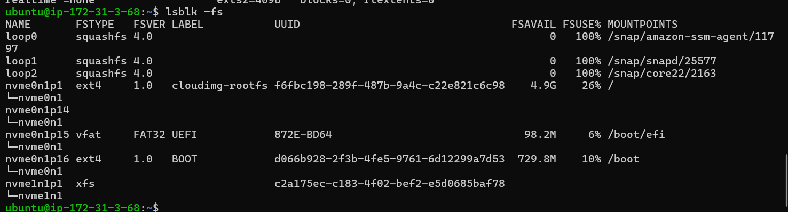

Step 8: Create a Mount Directory
mkdir /mnt/archana

Step 9: Mount the Volume
mount /dev/xvdf1 /mnt/archana
Verify:
df -h
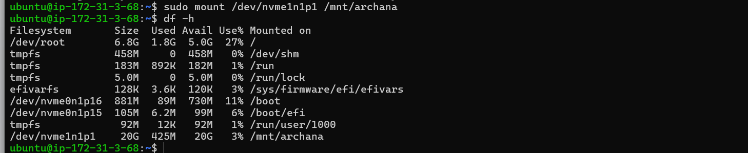

Step 10: Make the Mount Persistent
Get the UUID of the volume:
blkid /dev/xvdf1
Edit fstab:
nano /etc/fstab
Add this line at the end:
UUID=<UUID-value> /mnt/archana xfs defaults,nofail 0 0
Save and exit.
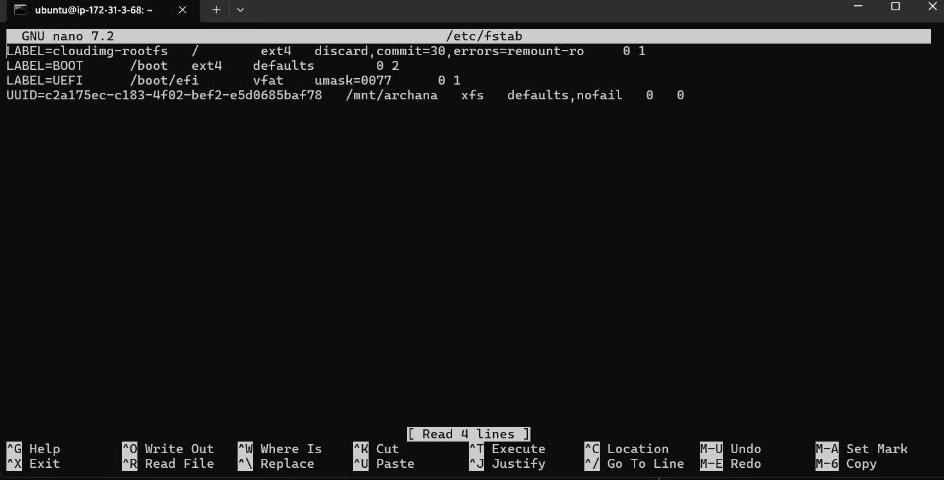
Test fstab:
mount -a

Step 11: Verify Persistence
- Reboot the instance:
reboot
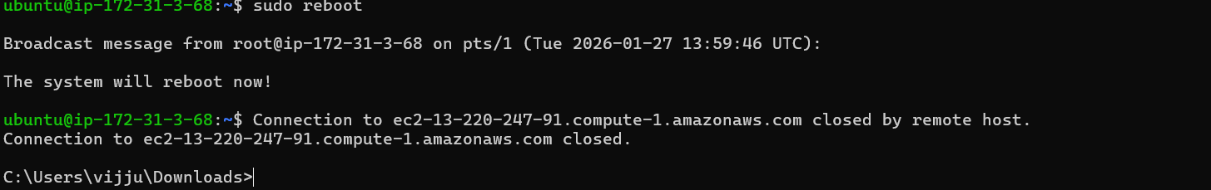
- Reconnect and check:
df -h
➡️ Volume should be mounted automatically.
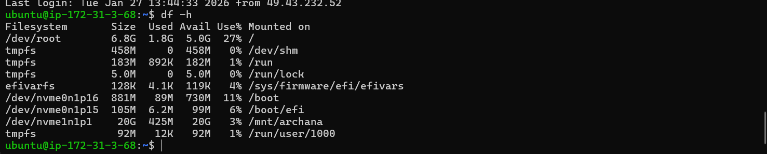

Step 12: Detach and Reattach Volume (Data Recovery Scenario)
Detach:
- EC2 → Volumes → Select volume
- Actions → Detach volume
Attach to another EC2 instance:
- Attach to new instance (same AZ)
- Login to new instance
- Create mount directory:
mkdir /mnt/archana
- Mount the volume:
mount /dev/xvdf1 /mnt/archana
All previous data will be available
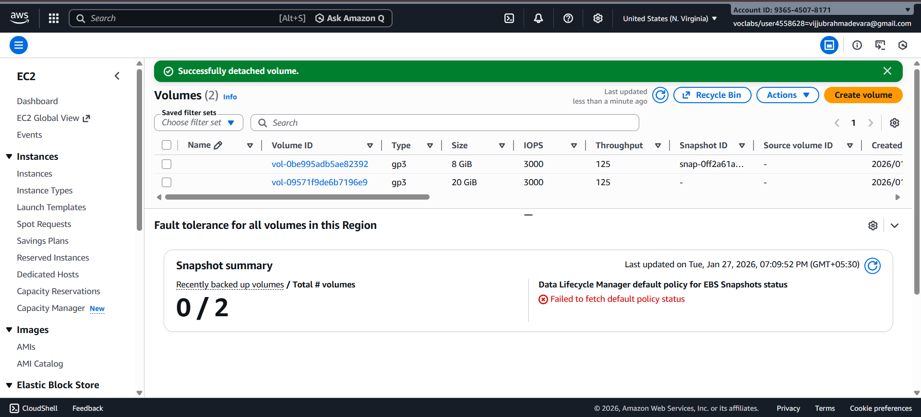

Summary Flow
Create Volume → Attach → lsblk → fdisk → mkfs → mkdir → mount → fstab → reboot

3. Create a snapshot of the attached EBS volume and use it to create and attach a new volume to an EC2 instance in another AWS region.
Attaching Volumes across regions of EC2 using the snapshot
To create a snapshot of an EBS volume and attach it to an instance in another region in AWS, you'll need to follow these steps:

Step 1. Create a Snapshot:
a. Sign in to the AWS Management Console.
b. Navigate to the EC2 Dashboard.
c. Click on "Volumes" in the left-hand navigation pane.
d. Select the EBS volume you want to create a snapshot of.
e. Click on the "Actions" dropdown menu above the volume list and select "Create Snapshot."
f. Provide a name and description for the snapshot.
g. Click on the "Create Snapshot" button to initiate the snapshot creation process.
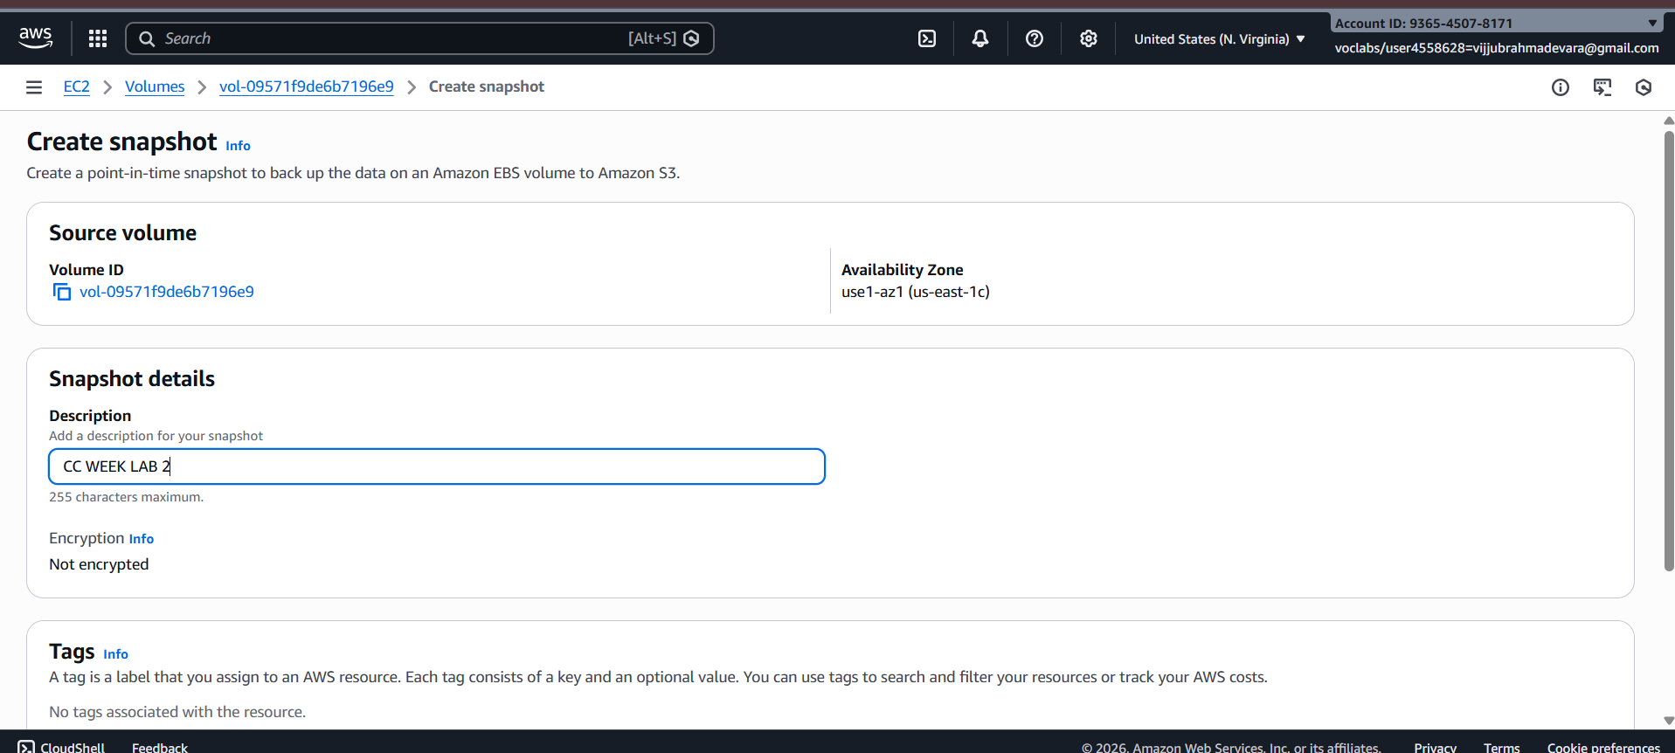

Step 2. Copy the Snapshot to Another Region:
a. Once the snapshot is created, go to the "Snapshots" section in the EC2 Dashboard.
b. Select the snapshot you just created.
c. Click on the "Actions" dropdown menu above the snapshot list and select "Copy Snapshot."
d. Choose the destination region where you want to copy the snapshot.
e. Click on the "Copy Snapshot" button to initiate the copy process. This may take some time depending on the size of the snapshot and the network speed.

Step 3. Monitor the Snapshot Copy Progress:
a. You can monitor the progress of the snapshot copy by navigating to the "Snapshots" section in the EC2 Dashboard of the source region.
b. Look for the snapshot you copied and check its status. It will change from "pending" to "completed" once the copy process is finished.
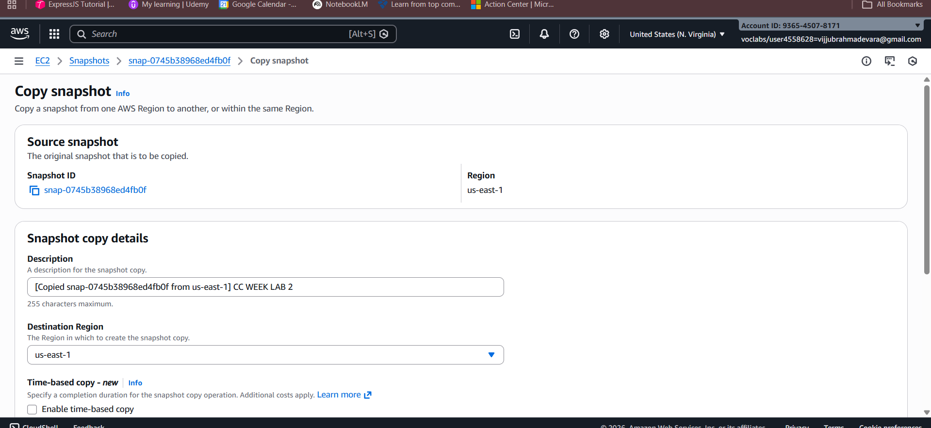
Step 4. Switch to the Destination Region:
- Use the region selector in the top-right corner of the AWS Management Console to switch to the destination region where you copied the snapshot.

Step 5. Create a Volume from the Snapshot:
a. In the EC2 Dashboard of the destination region, go to the "Snapshots" section.
b. Find the snapshot you copied from the source region.
c. Click on the snapshot, then click on the "Actions" dropdown menu and select "Create Volume."
d. Configure the volume settings, such as volume type, size, and availability zone.
e. Click on the "Create Volume" button to create the volume from the snapshot.
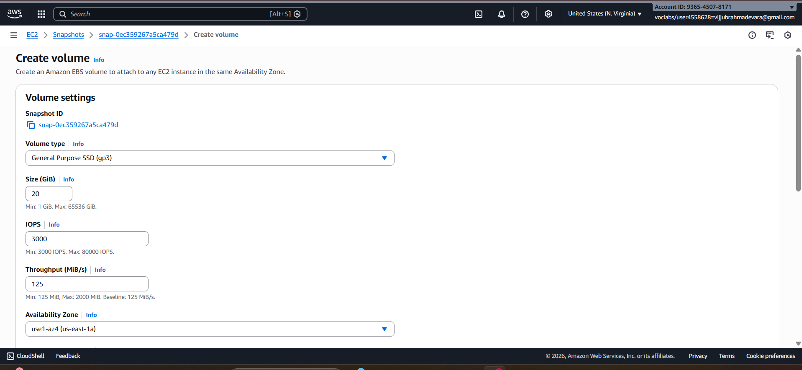

Step 6. Create the ec2 instance & Attach the Volume to an Instance:
a. Once the volume is created, navigate to the "Volumes" section in the EC2 Dashboard.
b. Find the newly created volume and select it.
c. Click on the "Actions" dropdown menu and select "Attach Volume."
D the EC2 instance to which you want to attach the volume and specify the device name.
e. Click on the "Attach" button to attach the volume to the instance.
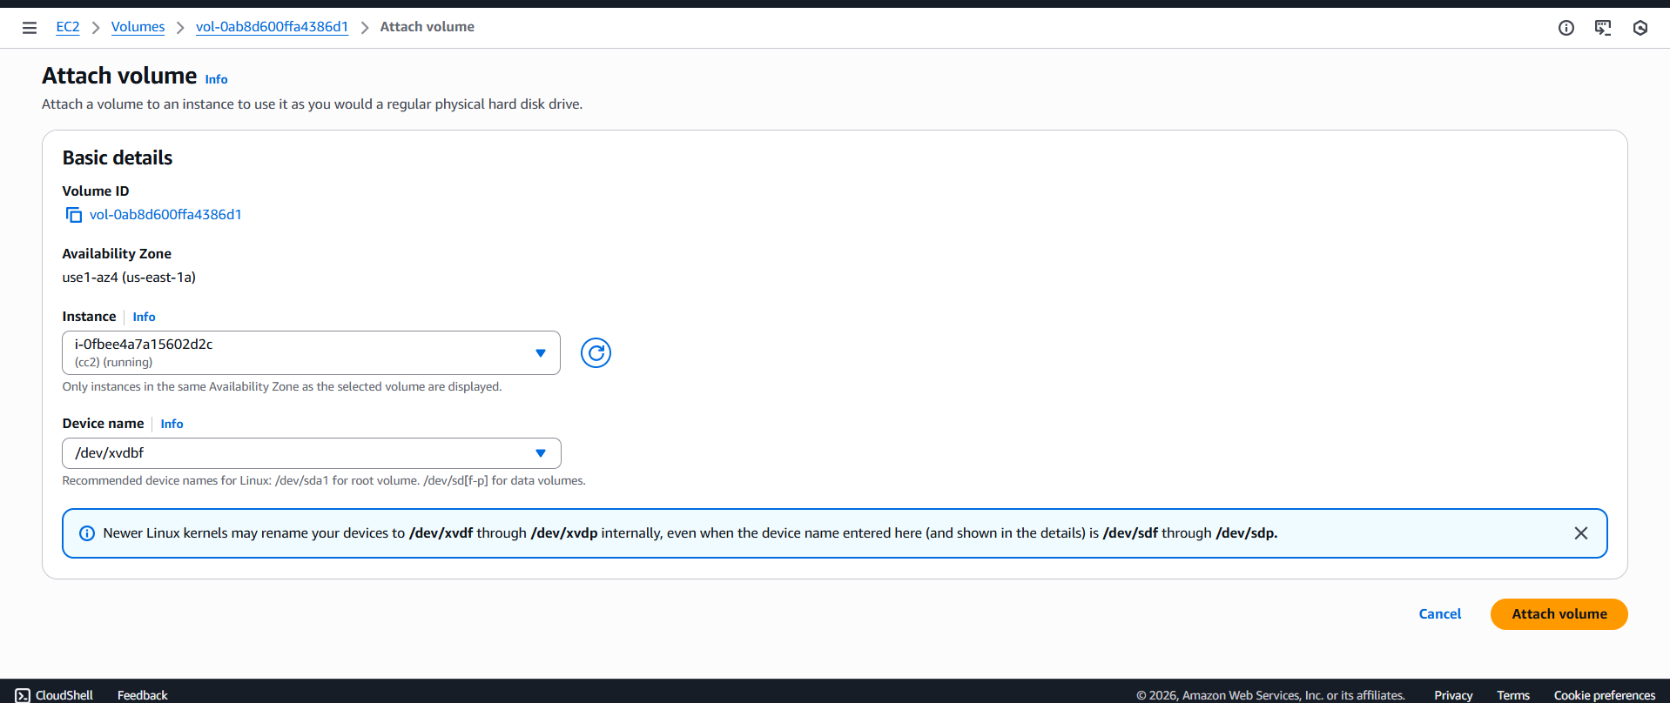
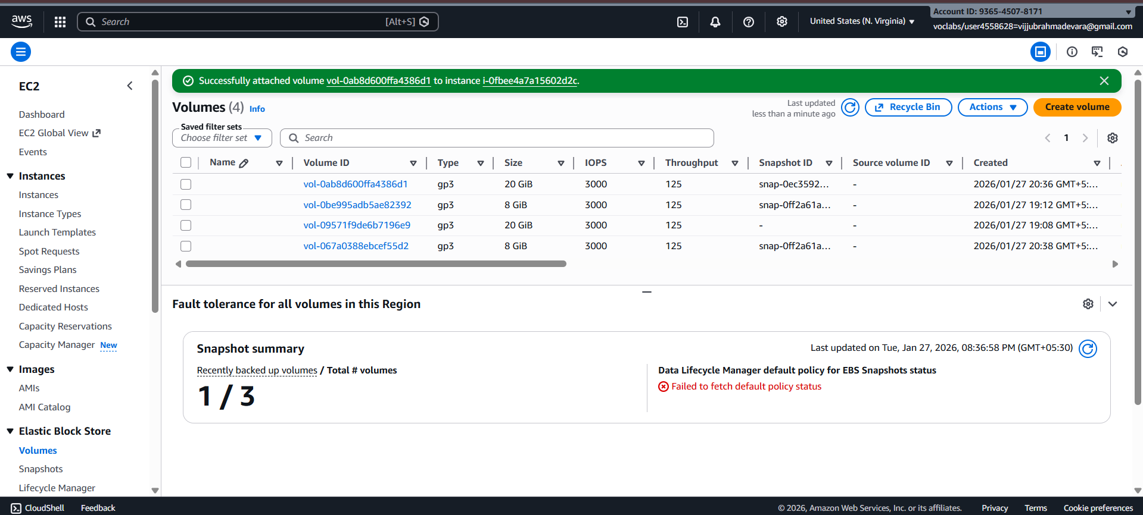
We have created a snapshot of an EBS volume, copied it to another region, created a volume from the snapshot, and attached it to an instance in the destination region.

Viva Questions:
1. Your database server crashed. Data must be recovered fast. What do you do?
Restore the latest EBS snapshot and attach it to a new EC2 instance.
Start the database service to resume operations quickly.
2. EC2 is deleted accidentally—how do you recover data?
Create a new EC2 instance and restore data from EBS snapshots.
Attach the restored volume to the new instance.
3. Root volume deleted with EC2. How do you prevent this next time?
Disable the Delete on Termination option for the root EBS volume.
This ensures the volume is preserved even if EC2 is terminated.
4. Disk is full in production EC2. What will you do?
Increase the EBS volume size and extend the filesystem.
Alternatively, attach a new EBS volume and move data.
5. You want to migrate EC2 to another AWS region.
Create an AMI or snapshot and copy it to the target region.
Launch a new EC2 instance from it in the destination region.
6. What happens to EBS when EC2 is stopped?
EBS volumes remain intact and data is preserved.
Only compute resources are stopped.
7. What happens to EBS when EC2 is terminated?
Root EBS volume is deleted by default.
Additional EBS volumes remain unless configured otherwise.
8. Application requires 20,000 IOPS. Which volume will you choose?
Provisioned IOPS SSD (io2 or io1) volume.
It supports high, consistent IOPS performance.
9. Can one EBS volume attach to multiple EC2s?
Generally no, EBS supports attachment to only one EC2.
Exception: io1/io2 Multi-Attach within the same AZ.
10. You deleted an EBS volume by mistake. How can you get it back?
Restore the volume from an existing snapshot.
Create a new volume using that snapshot.
11. What happens if a snapshot used by a volume is deleted?
The existing volume continues to work normally.
Only future restores from that snapshot become impossible.
12. Where are EBS snapshots stored?
EBS snapshots are stored in Amazon S3.
They are managed by AWS and are region-specific.

